**Lab 9: Tables**

1. Create the following tables with appropriate data types and constraints

|  |  |  |
| --- | --- | --- |
| ***Table Name: Users*** |  |  |
| **Column Name** | **Column Type** | **Notes** |
| NTID | text, max length of 20 | Primary Key |
| FirstName | text, max length of 50 | Required |
| MiddleInitial | text, max length of 1 | Optional |
| LastName | text, max length of 50 | Required |
| EmailAddress | text, max length of 100 | Optional |
| Password | text, max length of 50 | Optional |

CREATE TABLE Users (

NTID VARCHAR(20) PRIMARY KEY,

FirstName VARCHAR(50) NOT NULL,

MiddleInitial VARCHAR(1),

LastName VARCHAR(50) NOT NULL,

EmailAddress VARCHAR(100),

Password VARCHAR(50));

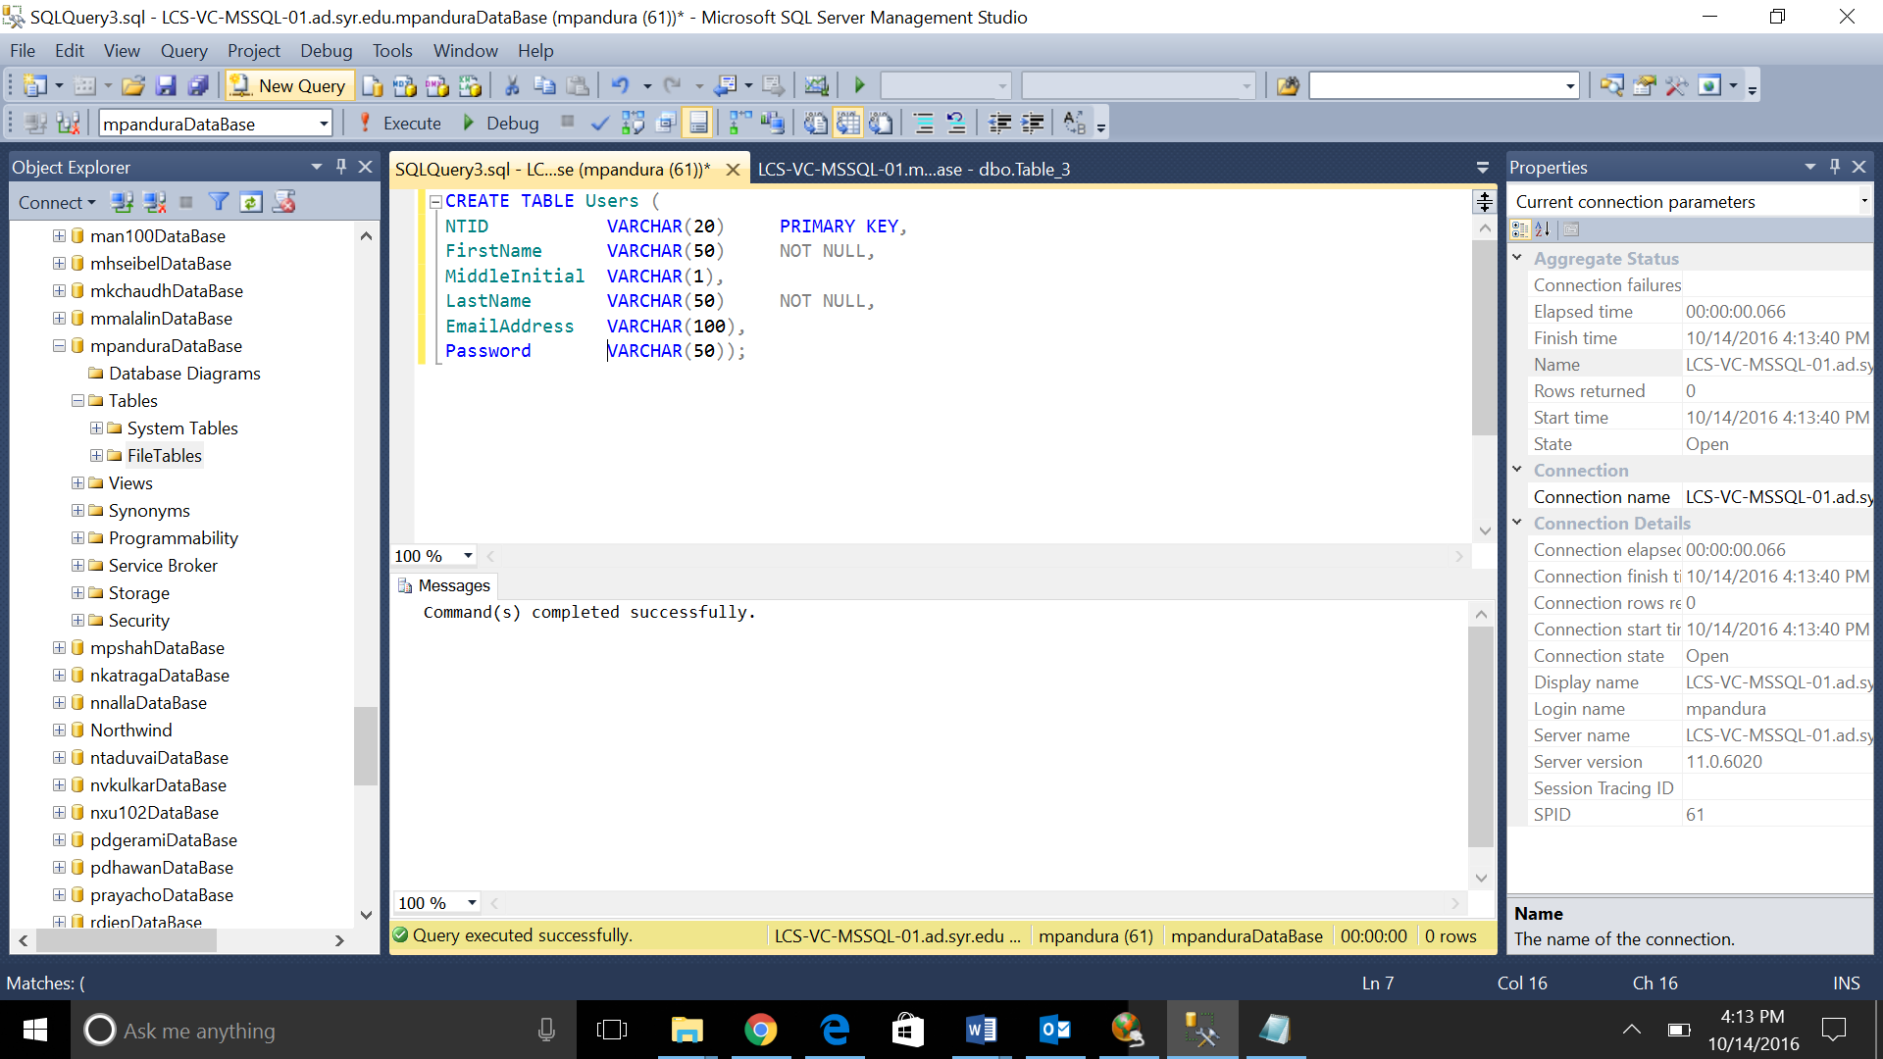

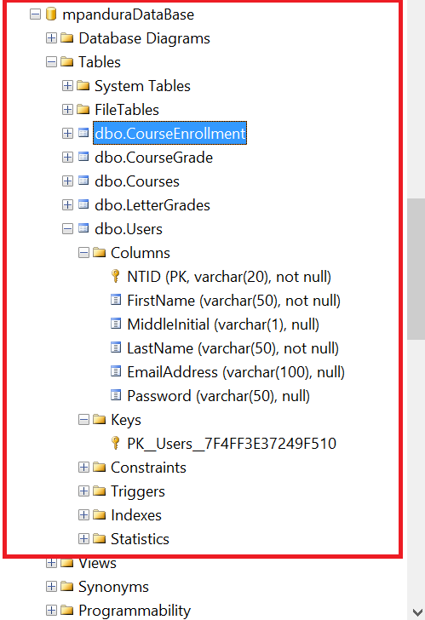

|  |  |  |
| --- | --- | --- |
| ***Table Name: Courses*** |  |  |
| **Column Name** | **Column Type** | **Notes** |
| CourseId | number | Primary Key, auto generated, starts at 1 |
| CourseCode | text, max length of 10 | Required |
| CourseTitle | text, max length of 50 | Required |
| Faculty | text, max length of 20 | Optional, references Users |
| OpenSeats | number | Required |

CREATE TABLE Courses (

CourseId INTEGER PRIMARY KEY IDENTITY(1,1),

CourseCode VARCHAR(10) NOT NULL,

CourseTitle VARCHAR(50) NOT NULL,

Faculty VARCHAR(20) REFERENCES Users(NTID),

OpenSeats INTEGER NOT NULL,

);

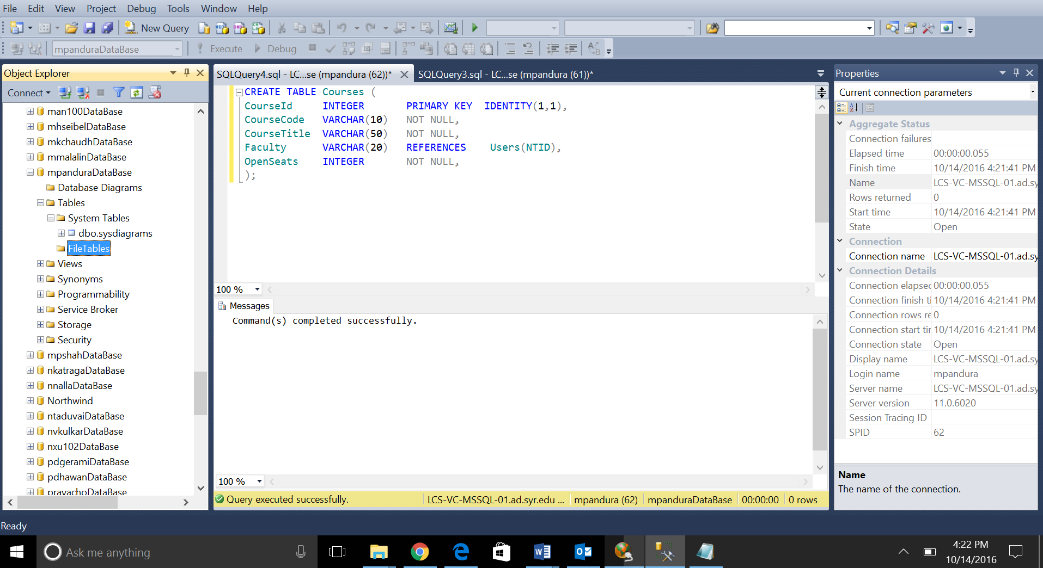

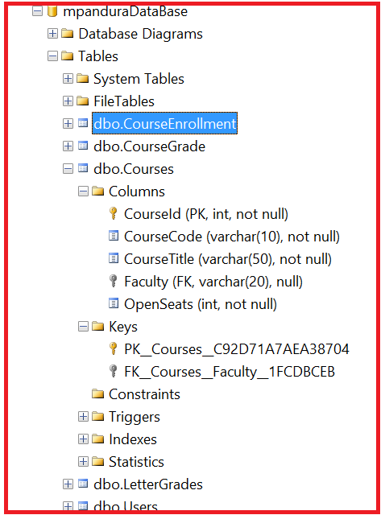

|  |  |  |
| --- | --- | --- |
| ***Table: LetterGrades*** |  |  |
| **Column Name** | **Column Type** | **Notes** |
| LetterGradeId | number | Primary Key, auto generated, starts at 1 |
| LetterGrade | text, max length of 2 | Required |
| Description | text, max length of 50 | Optional |

CREATE TABLE LetterGrades (

LetterGradeId INTEGER PRIMARY KEY IDENTITY(1,1),

LetterGrade VARCHAR(2) NOT NULL,

Description VARCHAR(50)

);

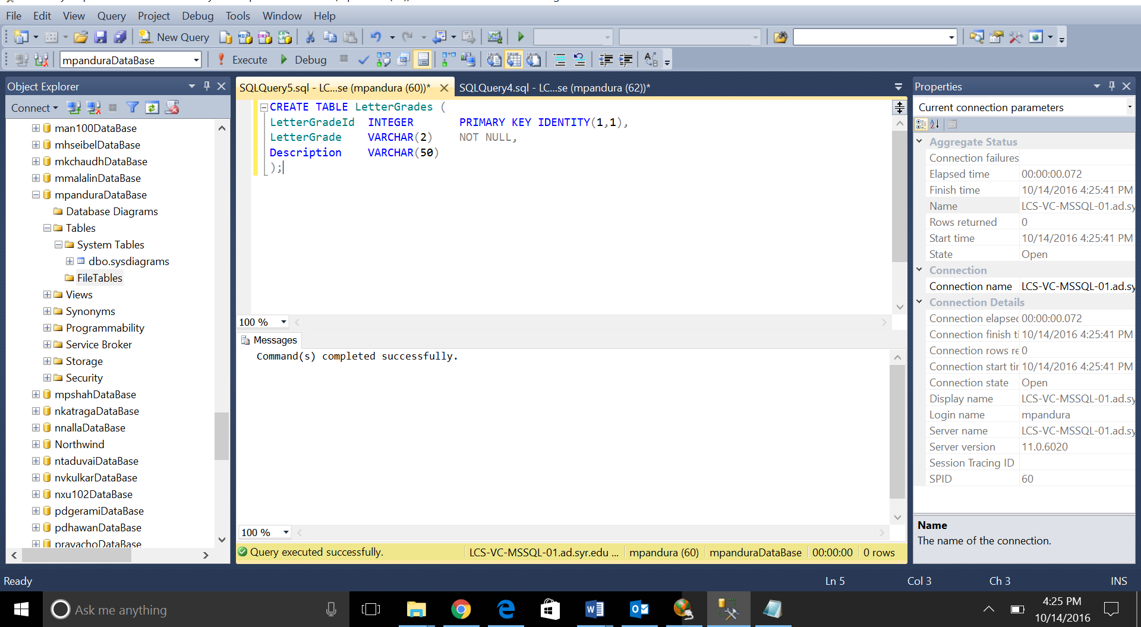

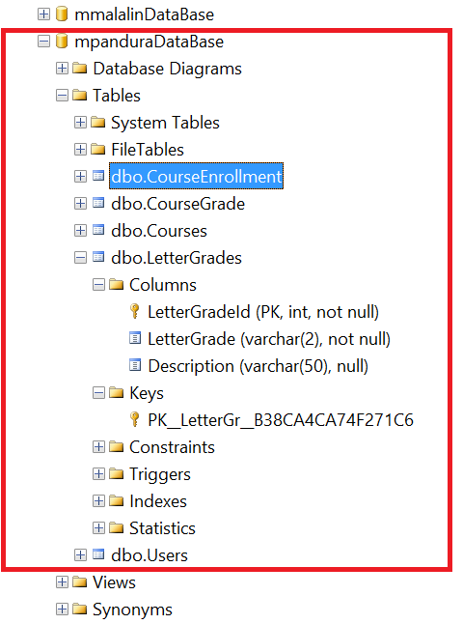

|  |  |  |
| --- | --- | --- |
| ***Table Name: CourseGrade*** |  |  |
| **Column Name** | **Column Type** | **Notes** |
| GradingScaleId | number | Primary Key, auto generated, starts at 1 |
| LetterGradeId | number | Required, references LetterGrades |
| CourseId | number | Required, references Courses |
| GradeValue | number | Required, >= 0 |

CREATE TABLE CourseGrade (

GradingScaleId INTEGER PRIMARY KEY IDENTITY (1,1),

LetterGradeId INTEGER NOT NULL REFERENCES LetterGrades(LetterGradeId),

CourseId INTEGER NOT NULL REFERENCES Courses(CourseId),

GradeValue INTEGER NOT NULL CHECK (GradeValue>=0)

);

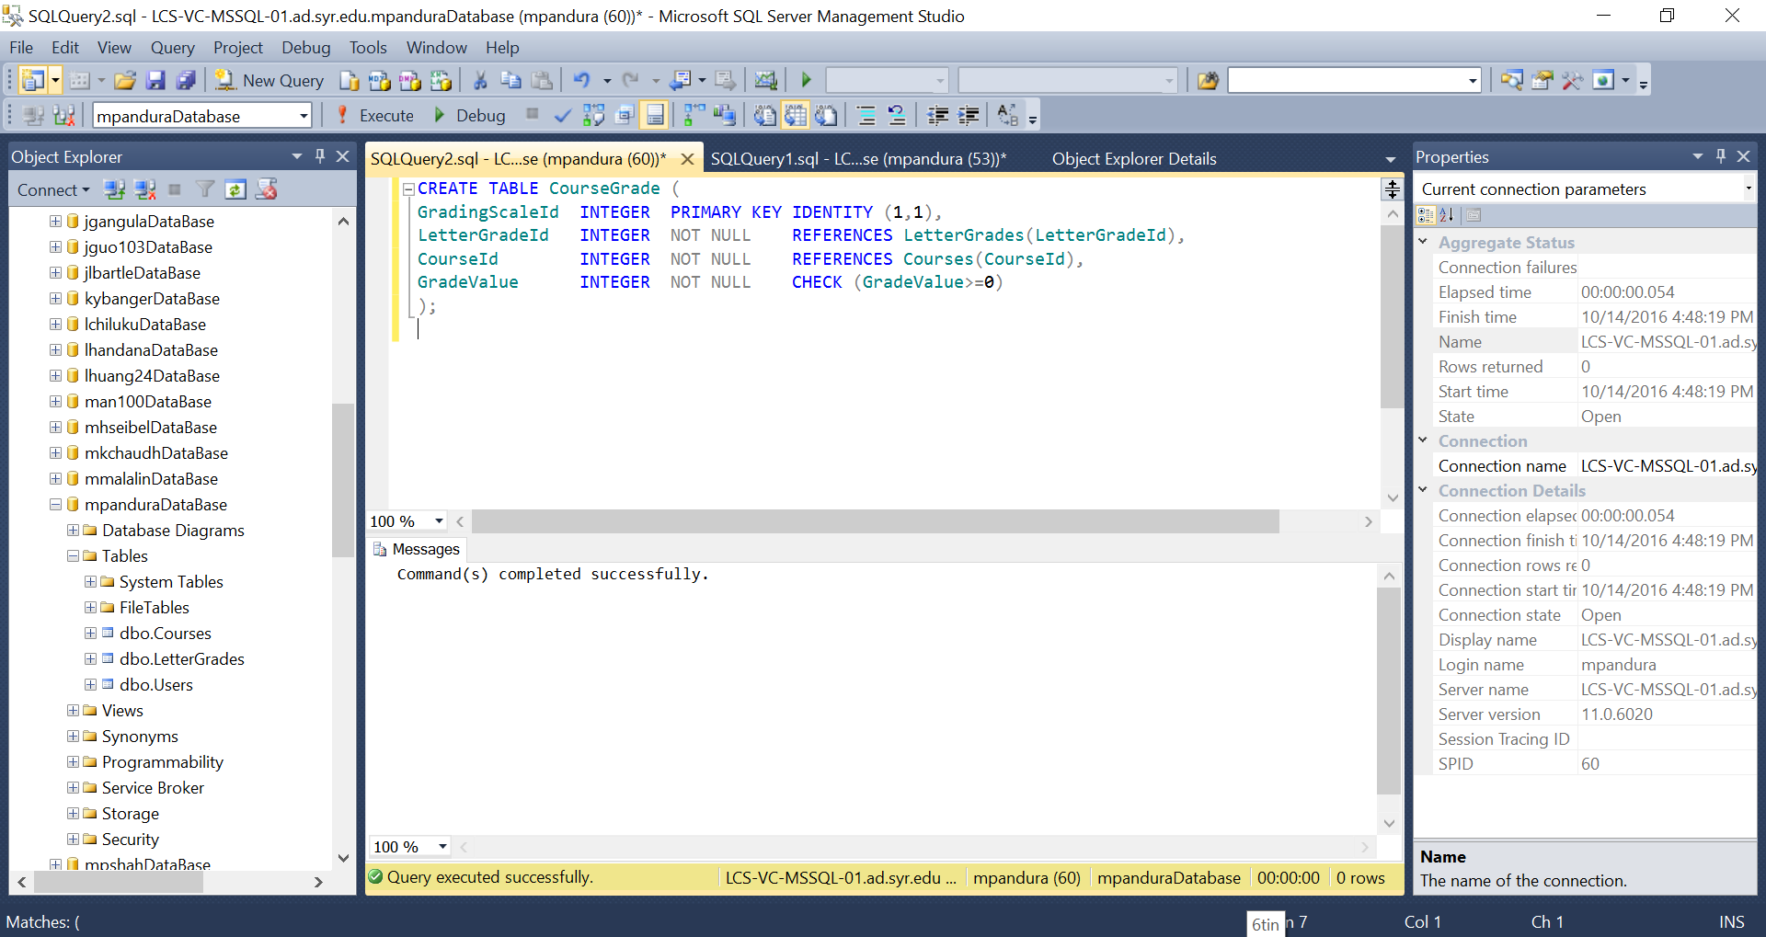

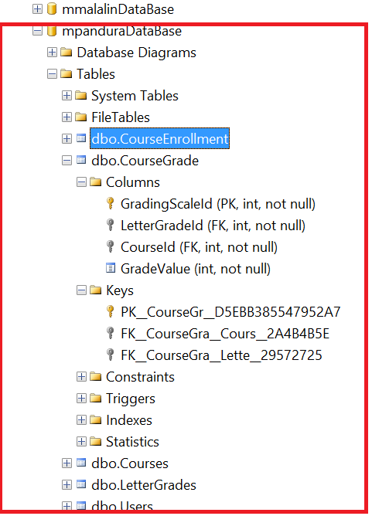

|  |  |  |
| --- | --- | --- |
| ***Table Name: CourseEnrollment*** | | |
| **Column Name** | **Column Type** | **Notes** |
| EnrollmentId | number | primary key, auto generated, starts at 1 |
| StudentId | text, max length 20 | Required, references Users |
| CourseId | number | Required, references Courses |
| FinalGrade | number | Optional, >=0.00, <=100.00 |

CREATE TABLE CourseEnrollment (

EnrollmentId INTEGER PRIMARY KEY IDENTITY(1,1),

StudentId VARCHAR(20) NOT NULL REFERENCES Users(NTID),

CourseId INTEGER NOT NULL REFERENCES Courses(CourseId),

FinalGrade Decimal(3,2) CHECK (FinalGrade>=0.00 AND FinalGrade<=100.00)

);

